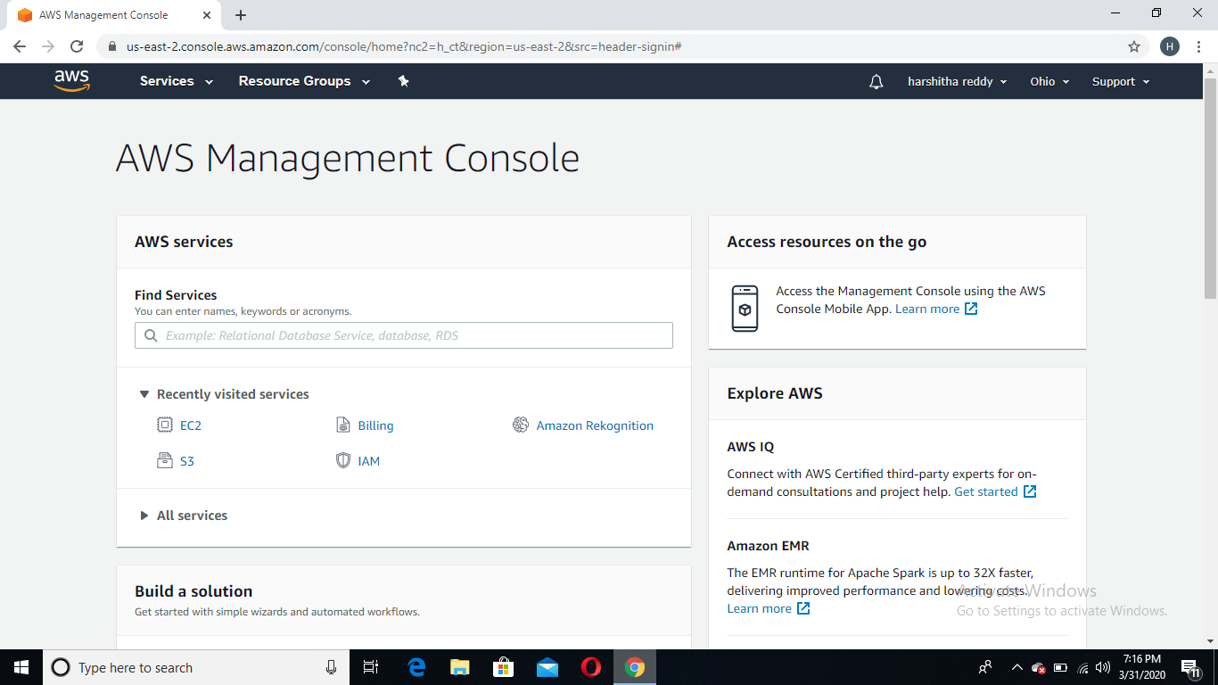

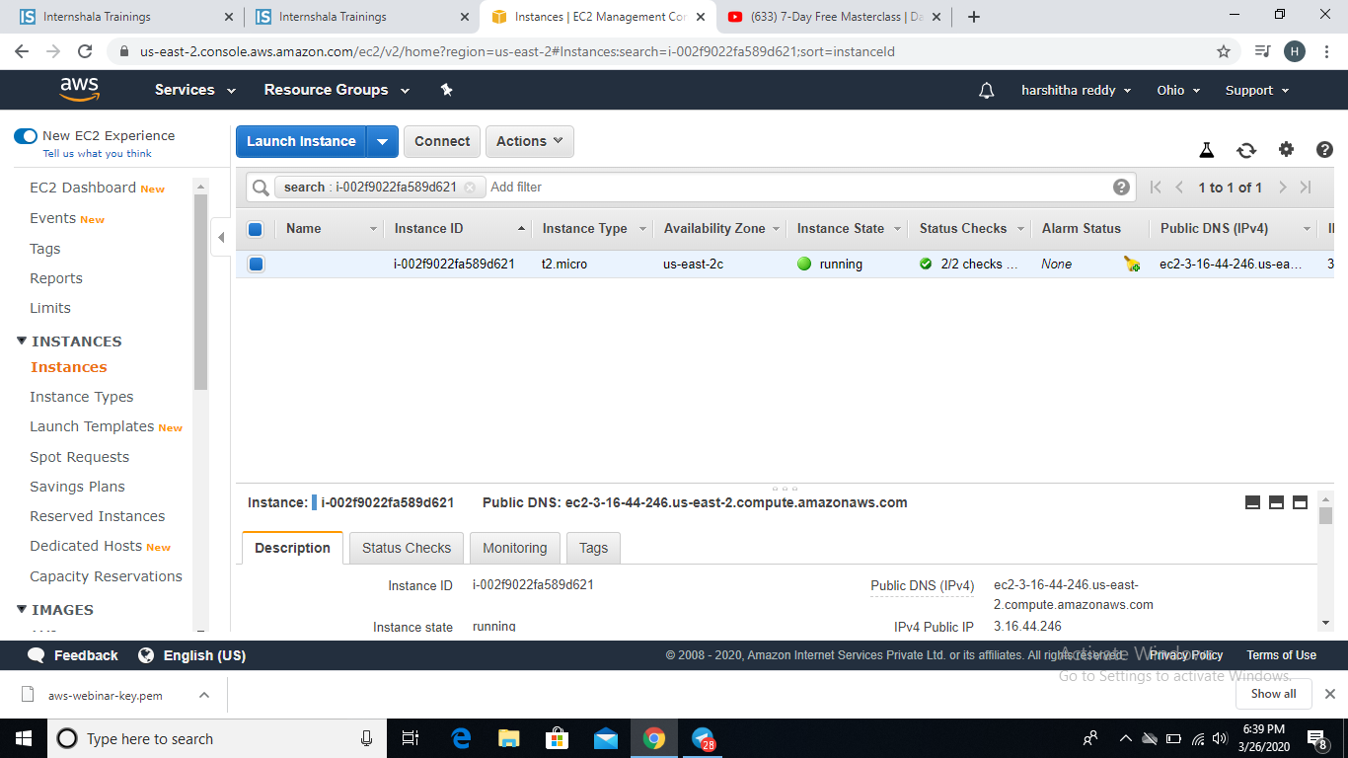

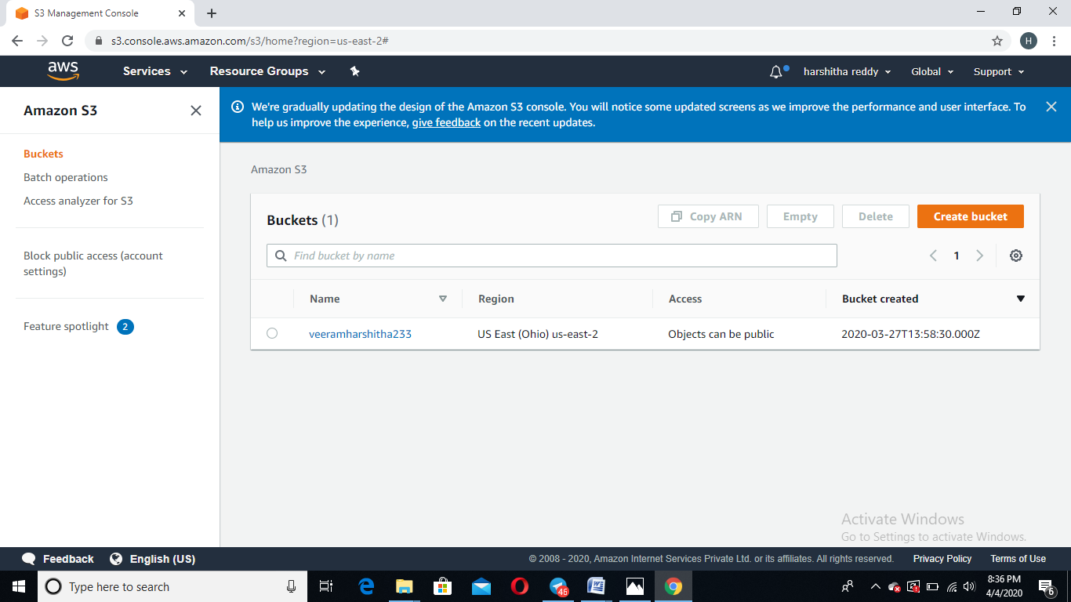

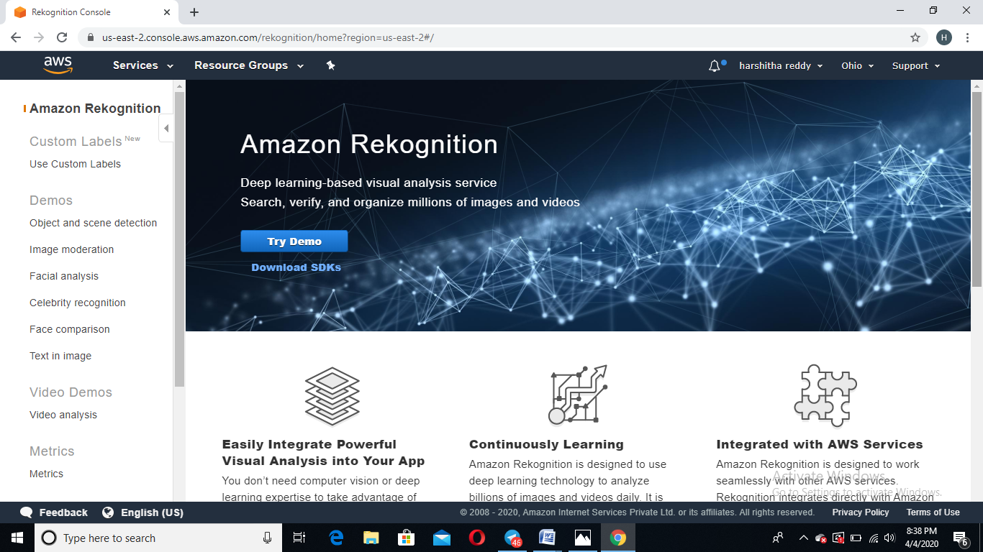

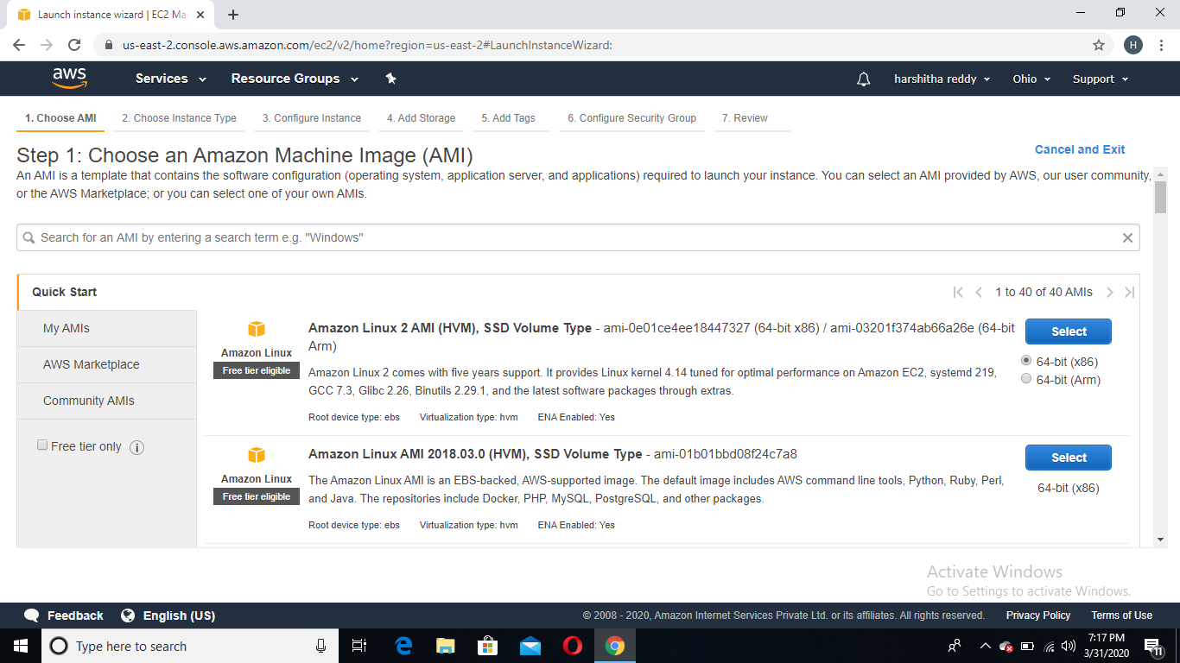

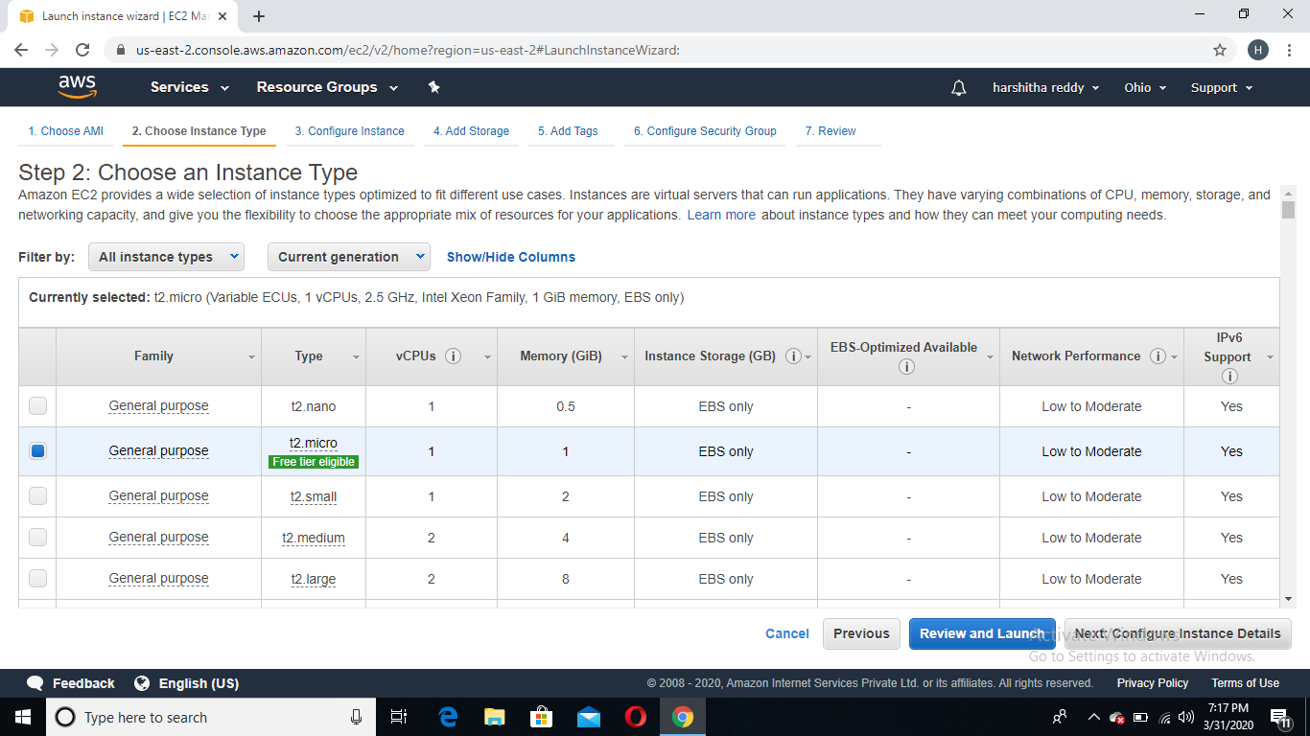

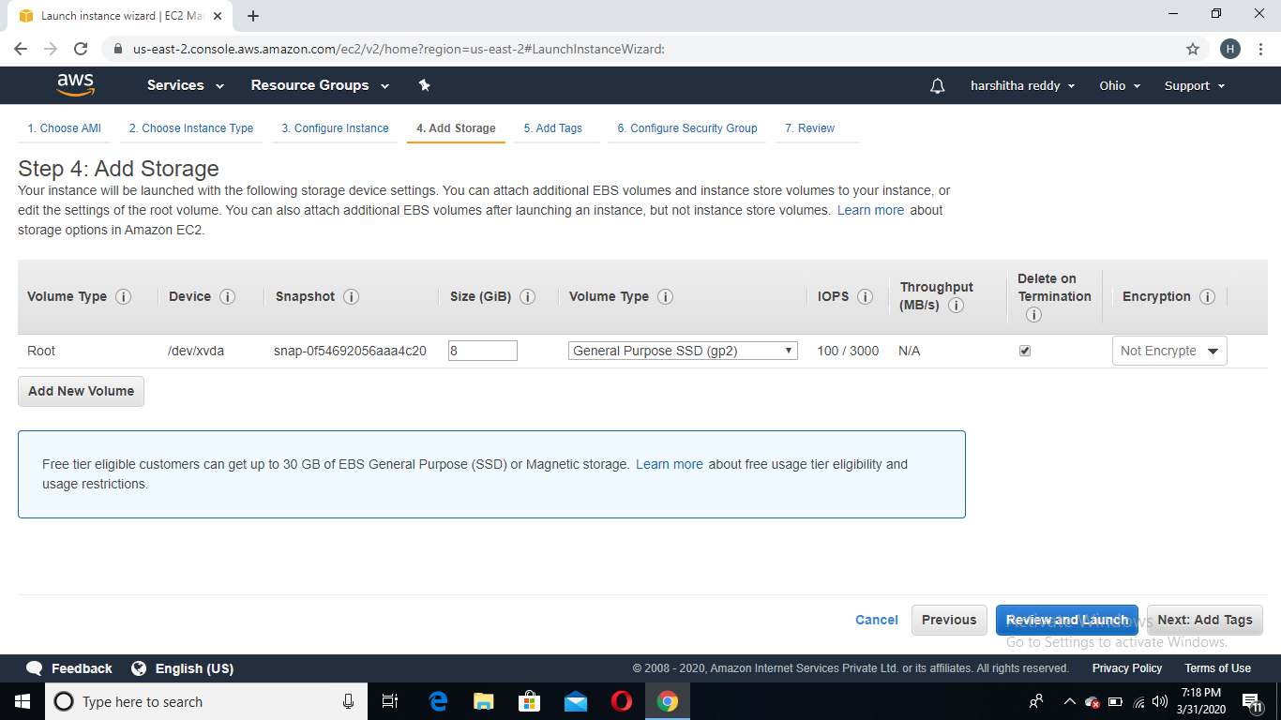

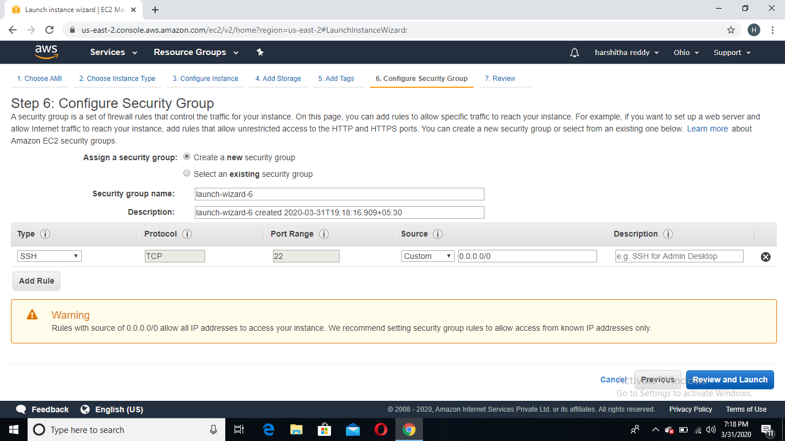

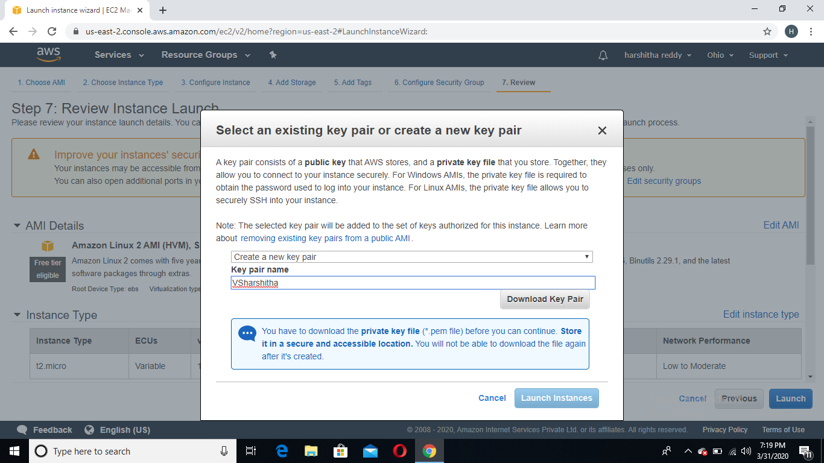

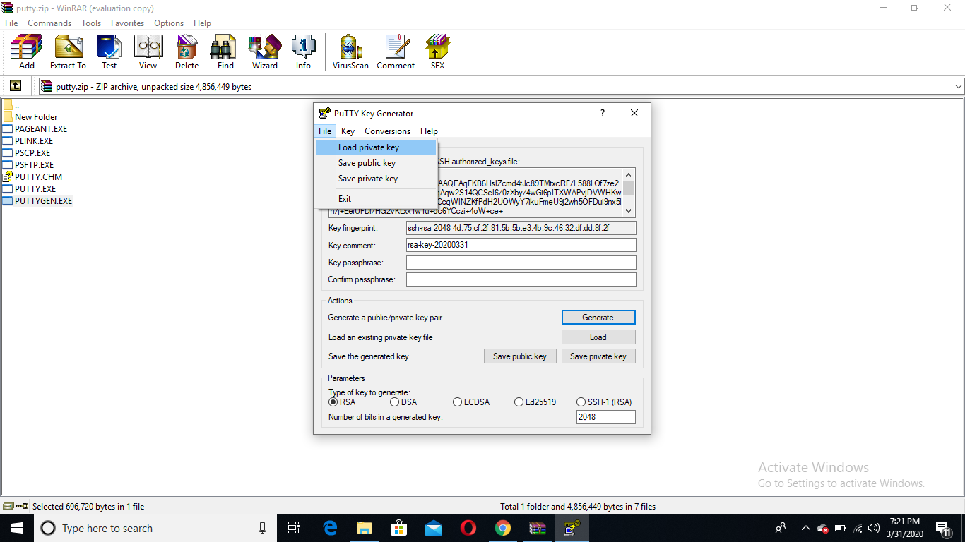

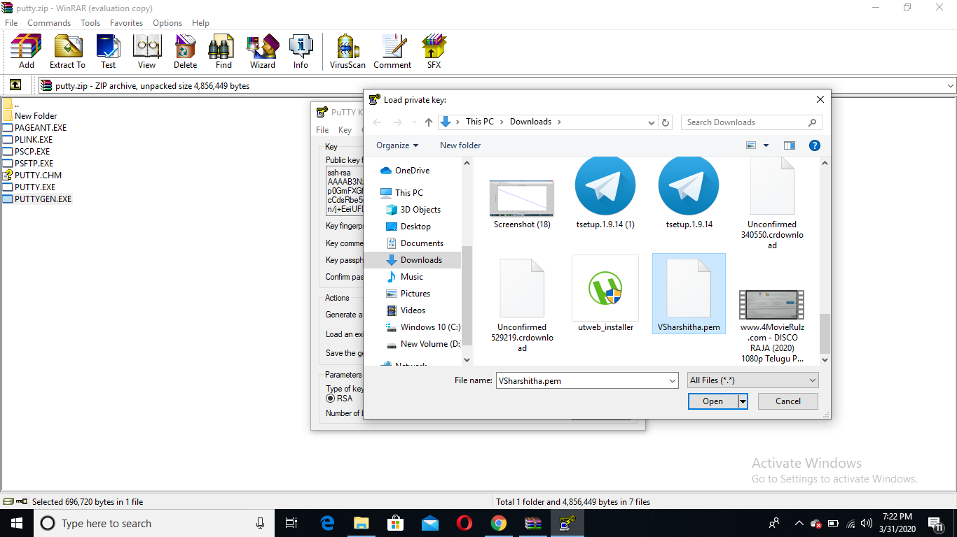

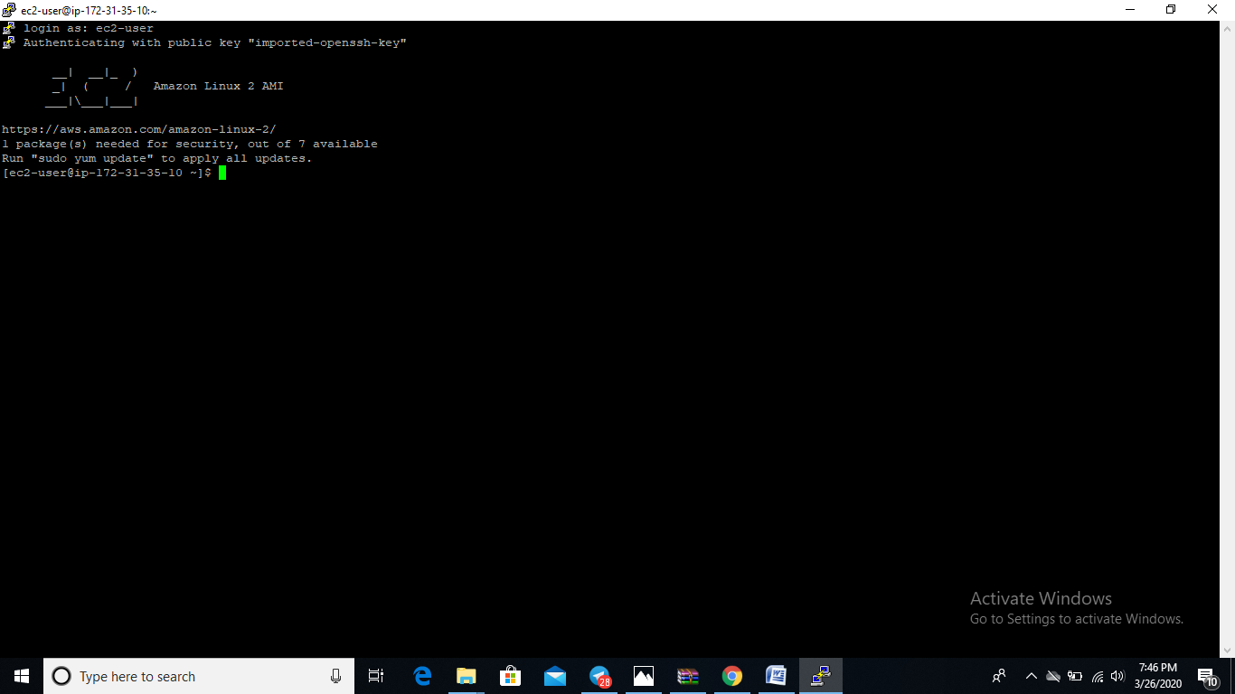

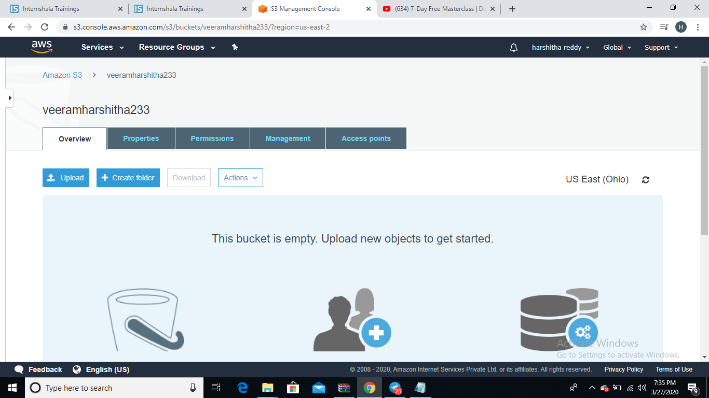

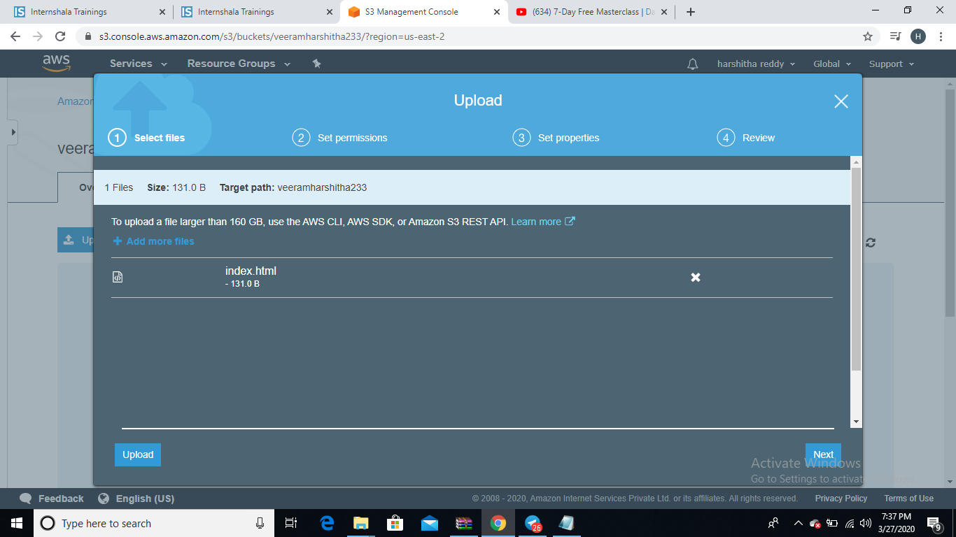

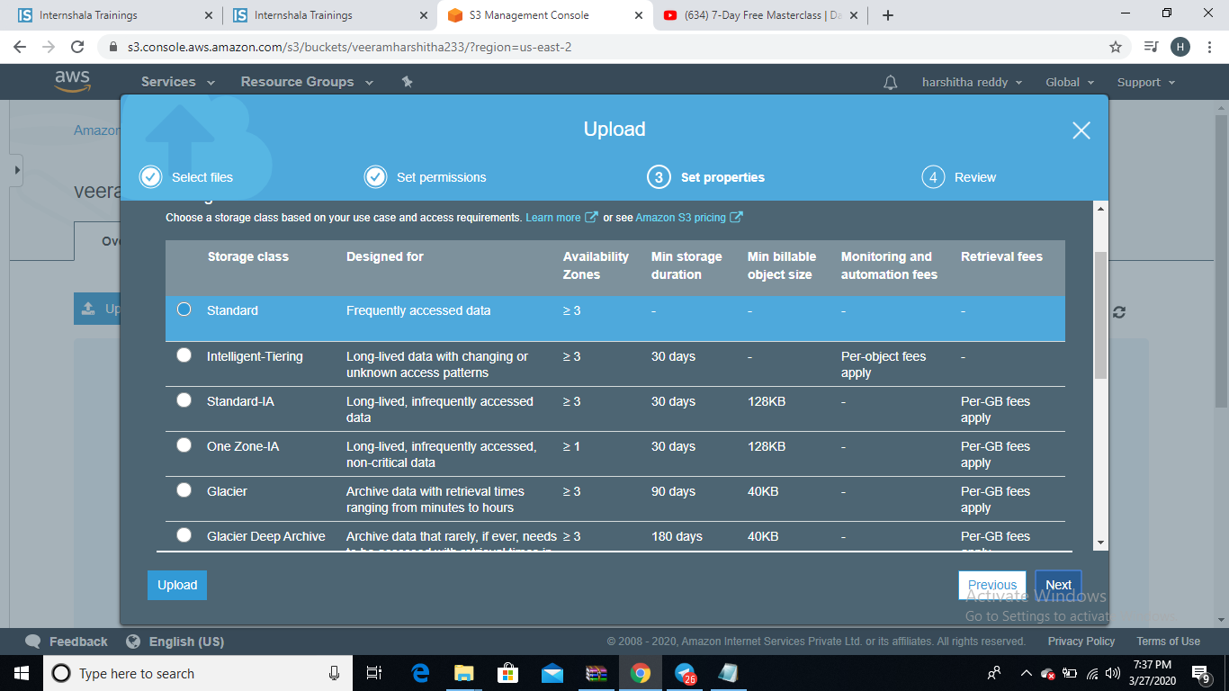

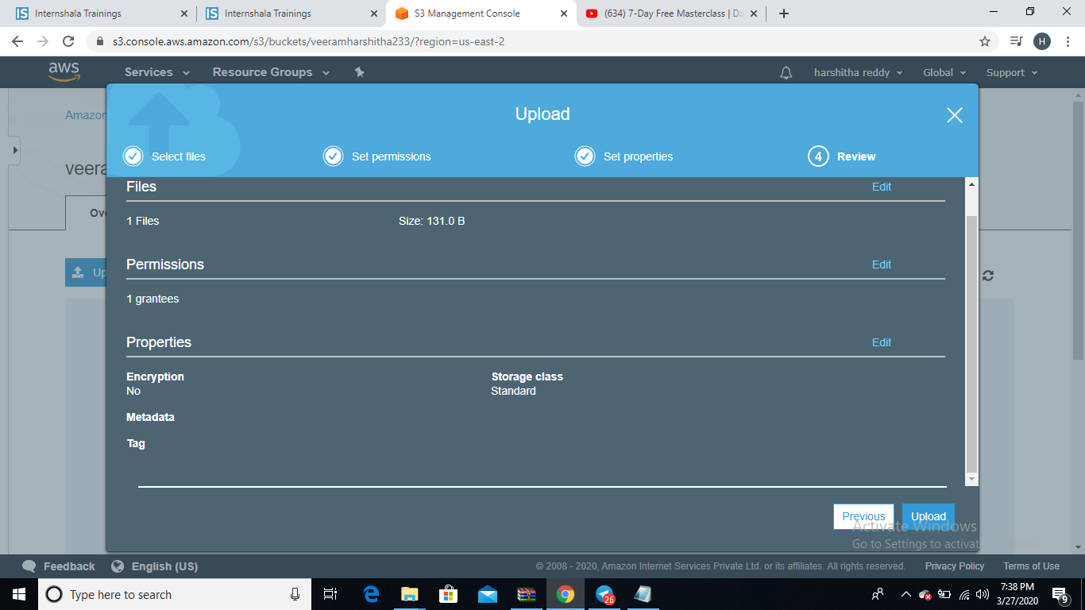

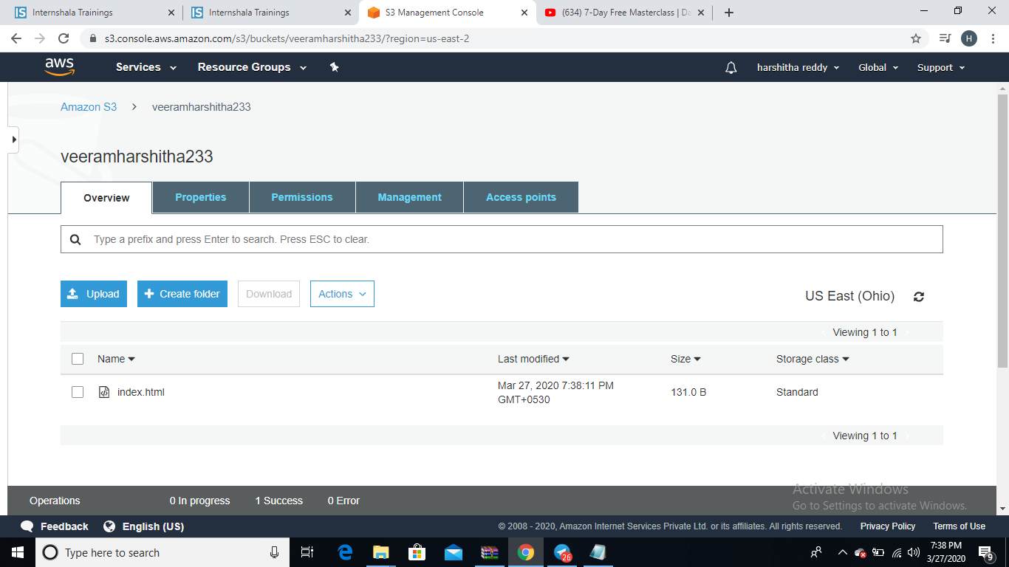

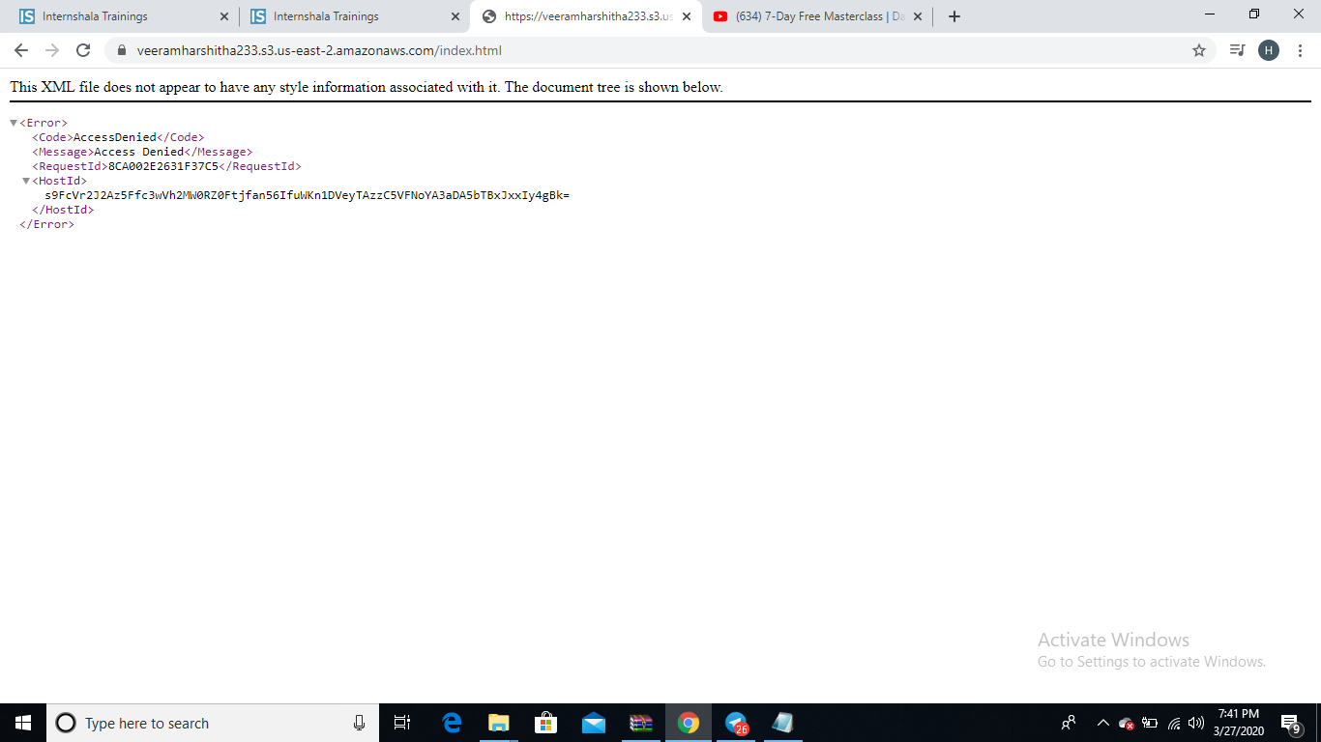

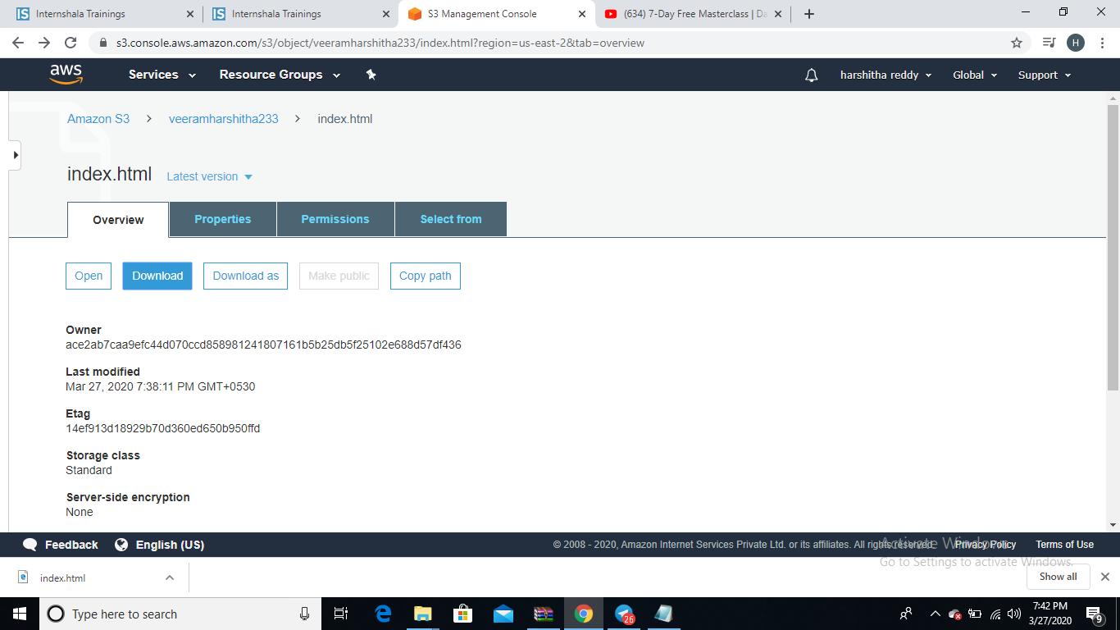

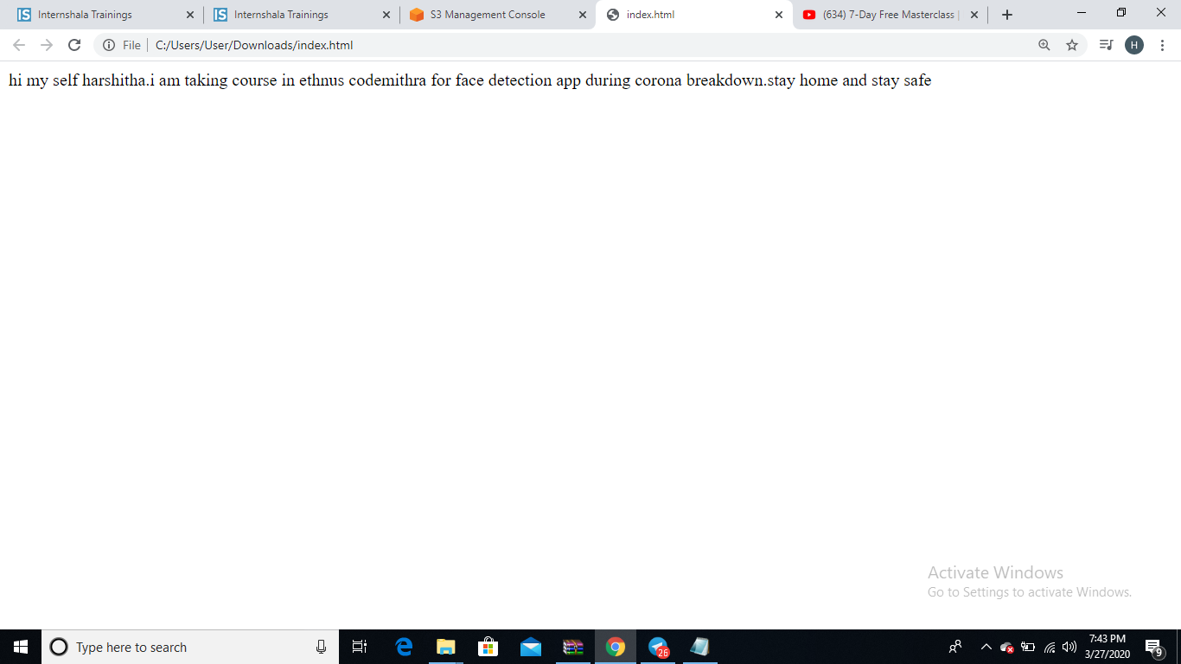

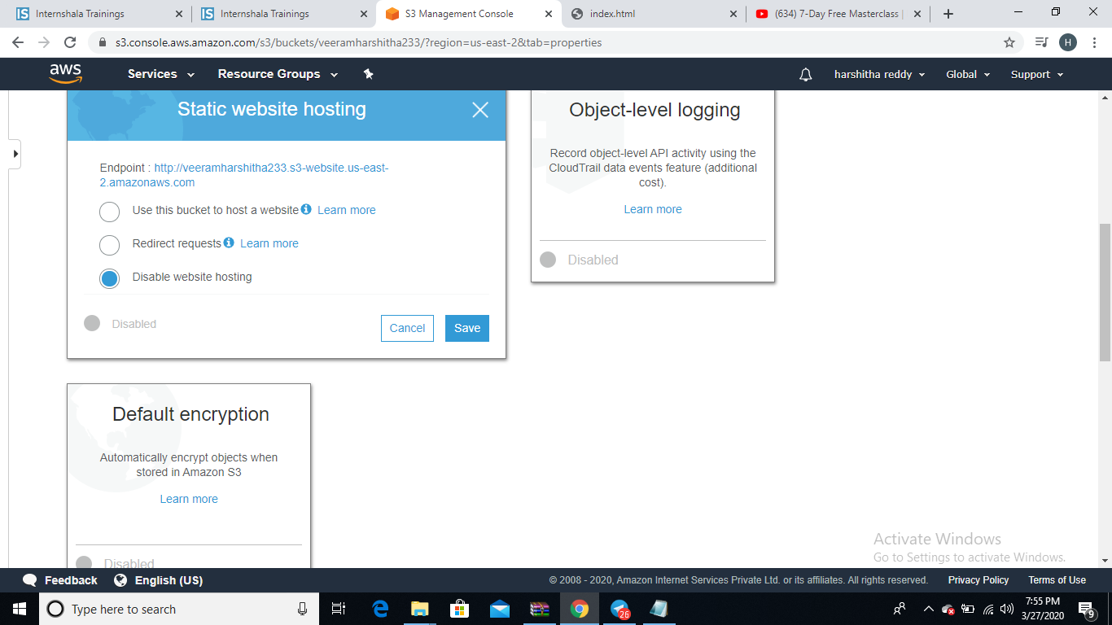

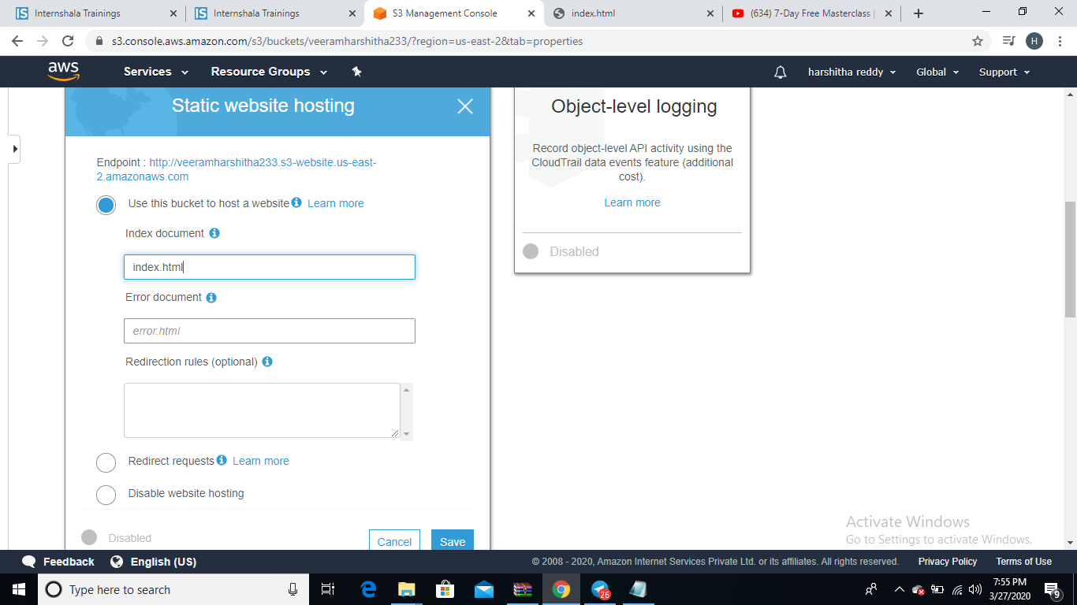

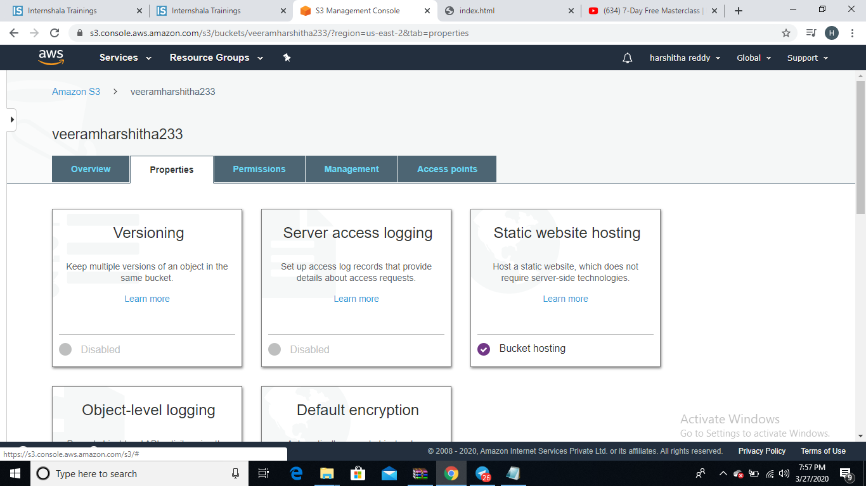

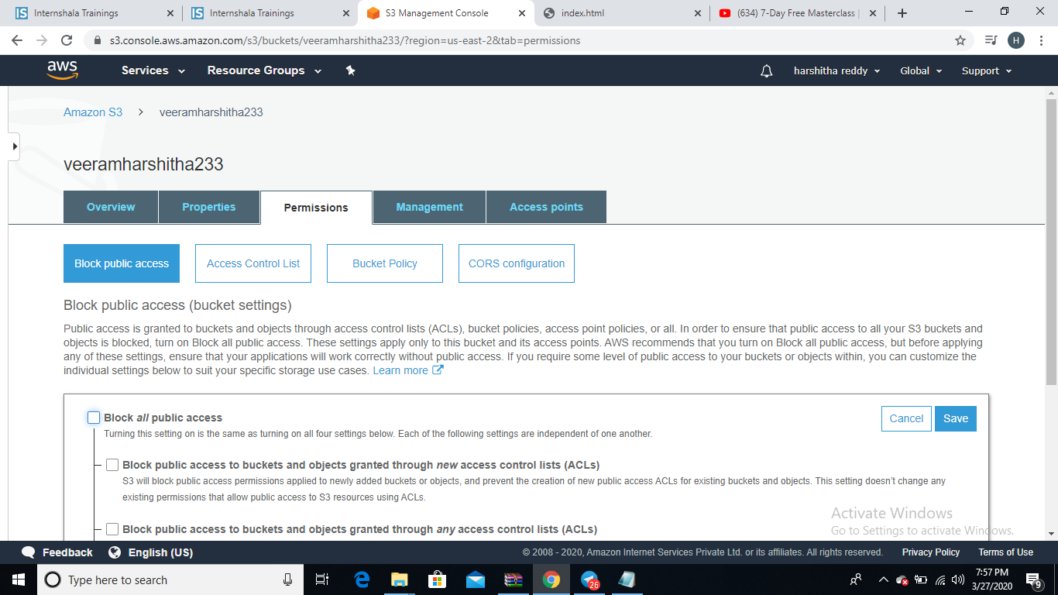

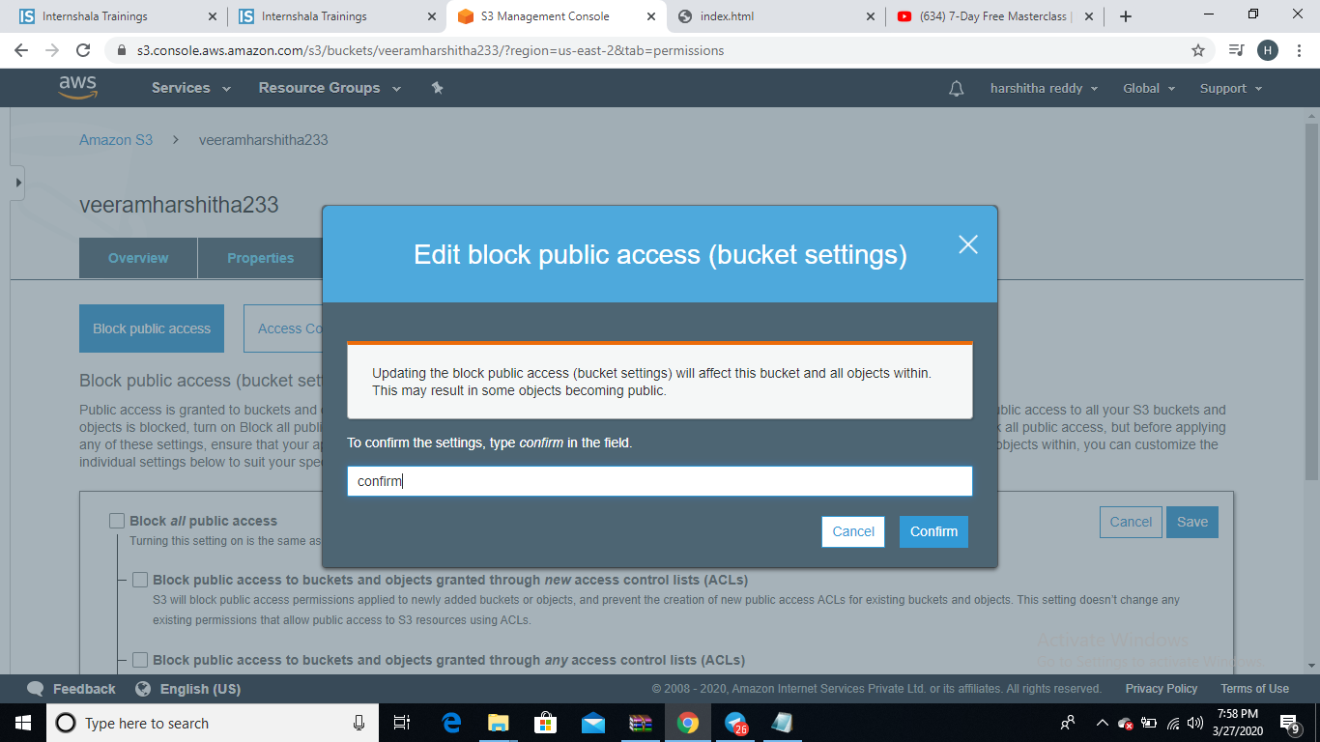

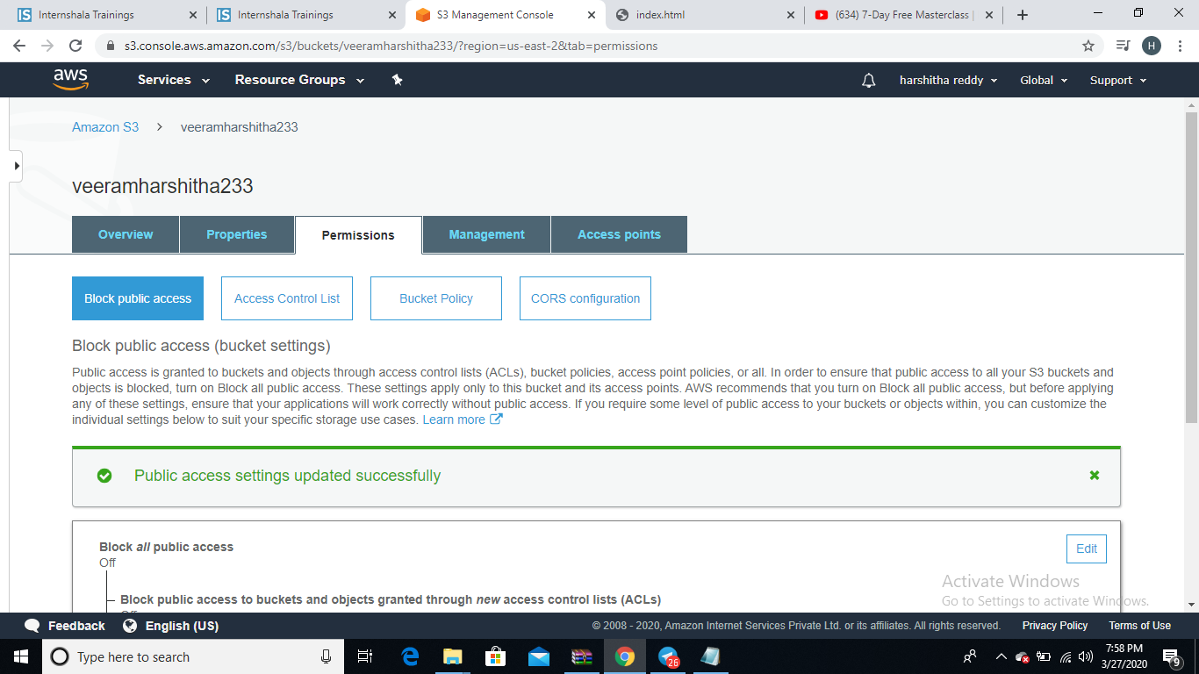

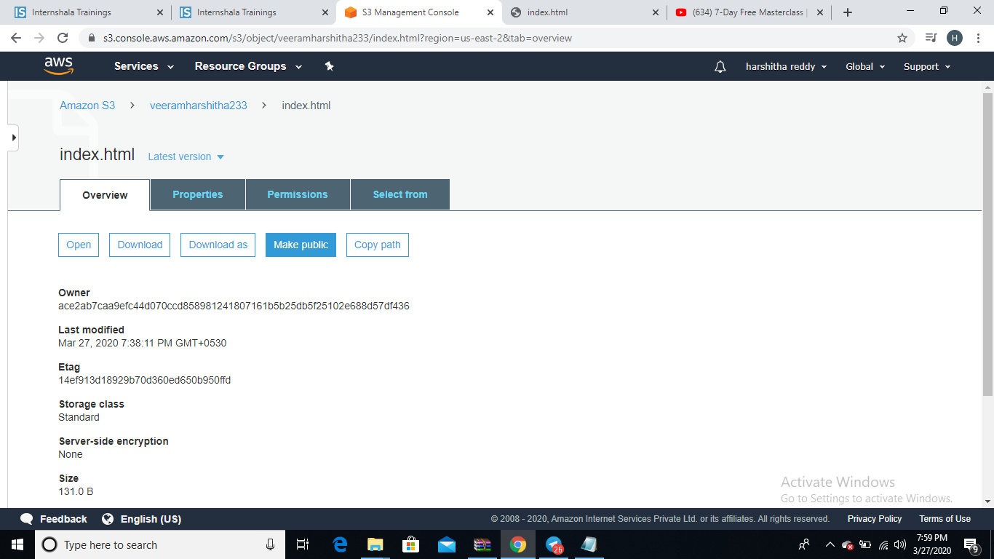

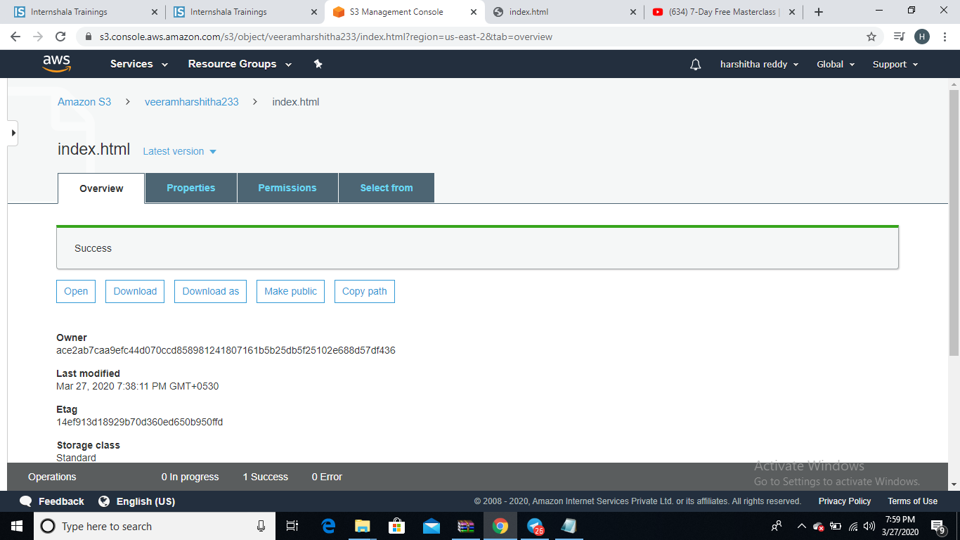

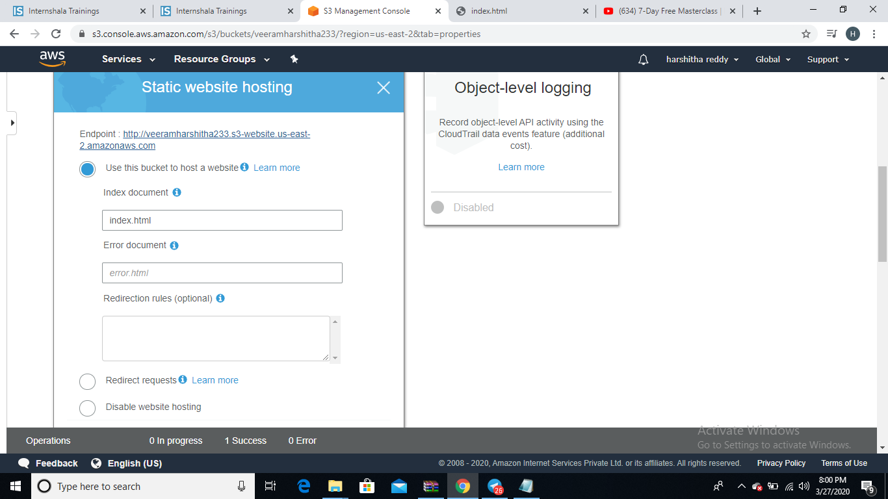

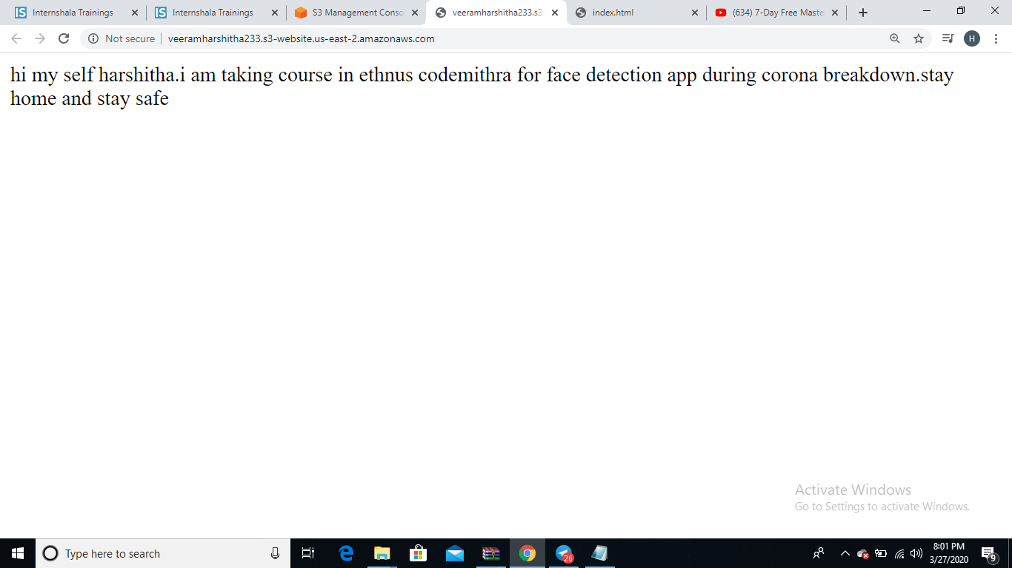

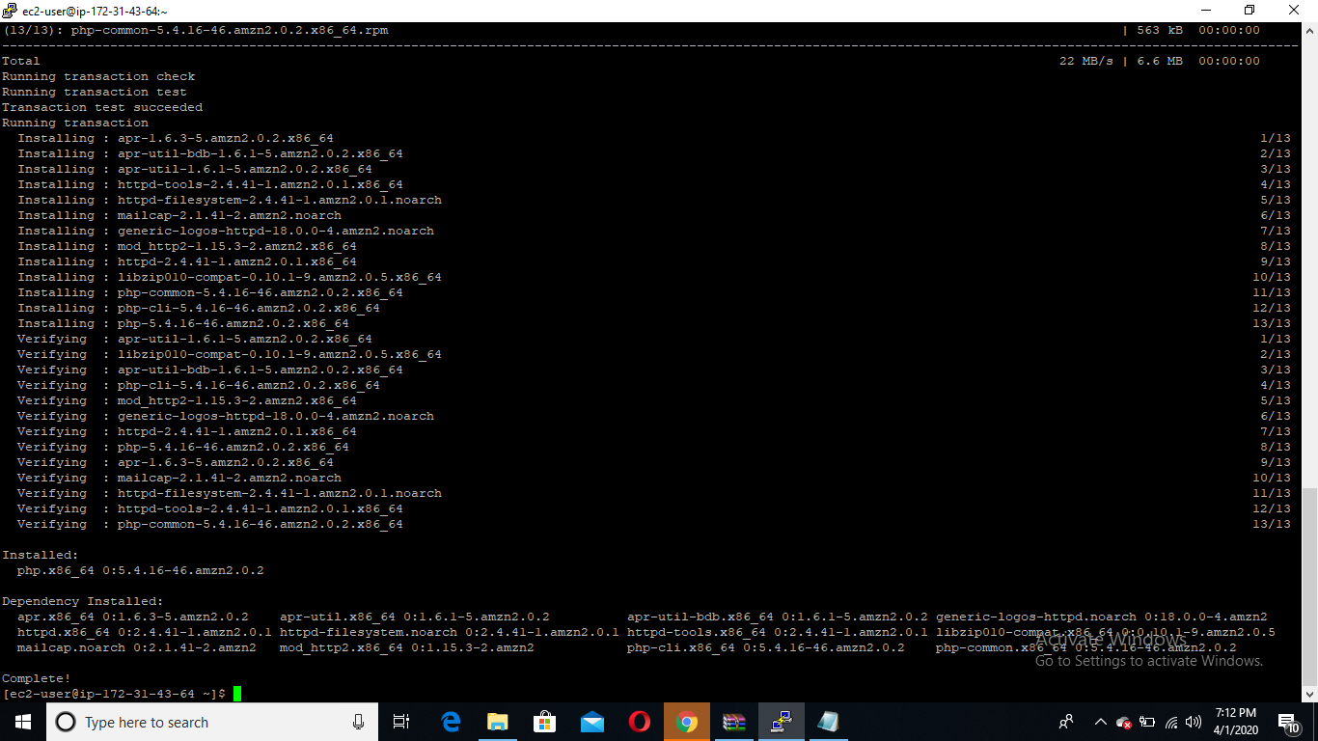

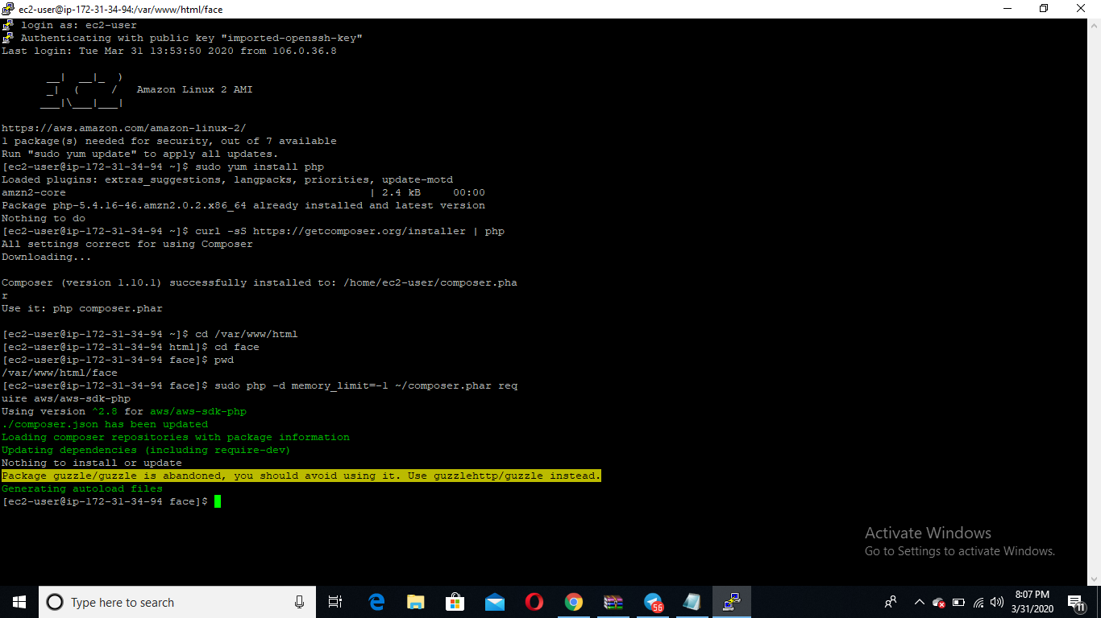

<?php

/*

Install php - sudo yum install php

curl -sS https://getcomposer.org/installer | php

cd /var/www/html

sudo mkdir face

cd face

sudo php -d memory_limit=-1 ~/composer.phar require aws/aws-sdk-php

In case if you get memory error -

sudo /bin/dd if=/dev/zero of=/var/swap.1 bs=1M count=1024

sudo /sbin/mkswap /var/swap.1

sudo /sbin/swapon /var/swap.1

sudo wget https://i.pinimg.com/originals/b9/7e/a3/b97ea33b5842c7894b804923c6c05580.jpg

sudo mv b97ea33b5842c7894b804923c6c05580.jpg s.jpg

*/

error_reporting(0);

require_once(__DIR__ . '/vendor/autoload.php');

use Aws\S3\S3Client;

use Aws\Rekognition\RekognitionClient;

$bucket = 'veeramharshitha233';

$keyname = 's.jpg';

$s3 = S3Client::factory([

'profile' => 'default',

'region' => 'us-east-2',

'version' => '2006-03-01',

'signature' => 'v4'

]);

try {

// Upload data.

$result = $s3->putObject([

'Bucket' => $bucket,

'Key' => $keyname,

'SourceFile' => DIR. "/$keyname",

'ACL' => 'public-read'

]);

// Print the URL to the object.

$imageUrl = $result['ObjectURL'];

if($imageUrl) {

echo "Image upload done... Here is the URL: " . $imageUrl;

}

} catch (Exception $e) {

echo $e->getMessage() . PHP_EOL;

}